



Technical Design documentation

Document History

|  |  |  |  |
| --- | --- | --- | --- |
| Version | Updated By | Date | Comments |
|  |  |  |  |
|  |  |  |  |
|  |  |  |  |

Document Sign-Off

|  |  |  |
| --- | --- | --- |
| Name | Role | Signature/Date |
|  |  |  |
|  |  |  |
|  |  |  |

Table of Contents

1. Introduction 3

2. Architectural Overview 4

2.1 Architectural Goals and Constraints 4

2.2 Use-Case View 4

2.3 Logical View 5

2.4 Process View 6

2.5 Deployment View 6

2.6 Implementation View 7

2.7 Security: Authentication and Authorization 7

3. Installation and Configuration 8

3.1 Configuration with PayPal 8

3.2 Installing Add-on 9

3.2.1 Downloading Add-on 9

3.2.2 Downloading Add-on 9

3.2.3 Update localextensions.xml 10

3.2.4 Run installation command 10

3.2.5 Main configurations 10

3.2.6 Rebuild the system 11

3.2.7 Update 11

4. Functional overview 12

4.1 PayPal Express checkout 12

4.2 PayPal Custom UI checkout along with other payment methods 16

4.2.1 Custom Braintree Integration with Hosted Fields 19

4.2.2 Replenishment orders for 5.7 B2B 20

4.2.3 Back-office operations with Braintree Payments 23

4.2.4 Find Braintree Transaction Section 23

4.2.5 Find Braintree Transaction Section 27

4.2.6 Error Handling 35

1. Introduction

It contains both architectural details of add-on design and functional description.

The add-on main goal was to integrate complete Braintree v.zero flow including the most up-to-date features with the latest versions of hybris Commerce Suite (5.2-5.7).

Please be aware that the customization is necessary while implementing particular projects. As a result, you need to go through this overview and check which of your project requirements are covered by out- of-the-box add-on and which of them require additional development.

Braintree hybris Add-on extends default hybris Commerce Accelerator Multistep Checkout Flow therefore it can be installed only on hybris Commerce Accelerator storefront.

In case applying this plugin to non-accelerator storefront only BrainTree (contained hybris BrainTree payment adapter) and braintreecscockpit extensions can be used. Appropriate addon extension (**braintreeaddon/braintreeb2baddon/braintreeb2ccheckoutaddon**) should be replaced with custom extension implemented for integration hybris Braintree payment adapter with custom merchant storefront using given Braintree hybris Add-on as example.

**Affected hybris out of the box applications**

The key criteria are the process of payment registering and/or order management in an application.

|  |  |
| --- | --- |
| **Application** | **Pages and components to affect** |
| B2B Accelerator web (version 5.7) | Footer section of all pages  Mini-cart pop up  Cart Page  Multi Checkout Page (Payment Details Step)  Multi Checkout Summary Page  Order Confirmation Page  My Account Payment Details Page  Replenishment Checkout Confirmation Page  Schedule Order Details Page Confirmation page Order details page |
| CS Cockpit | Add Braintree section:   * Find Braintree Transaction * New Transaction * New Transaction by Vault * Find Braintree Customer   Orders-> Cancel Order  Orders-> Refund Order |
| hMC (hybris Management Console) | Orders->Payment and Delivery->Administration  User->Customer->Administration |
| hAC (hybris Administration Console) | Platform->Configuration->keys starting from Braintree |

1. Architectural Overview

## Architectural Goals and Constraints

The main goal for Braintree-hybris integration is end-to-end solution, which can be used by merchants and developers with the most recent hybris platforms. This solution should be easy to plug in, configure, and extend for particular business needs.

## Use-Case View

General Braintree v.zero payment flow was used in the integration and it is depicted on the diagram below:

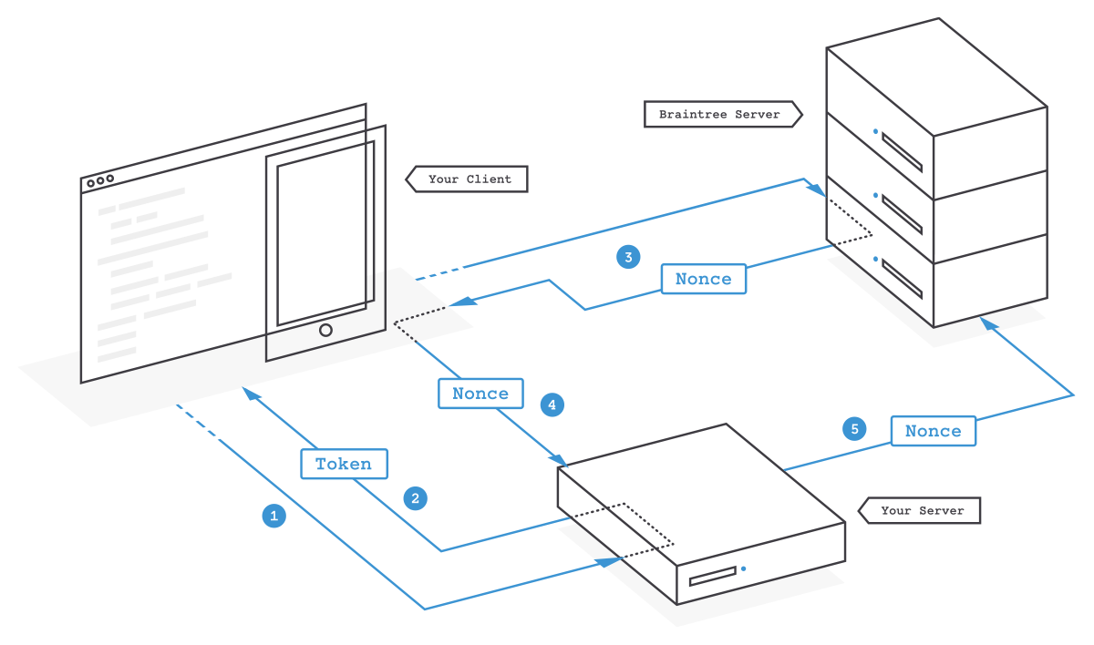

*Figure 1. Braintree v.zero Checkout flow*

Plugin Checkout flow consists of next steps:

1. Braintree payment adapter generates client token using Braintree Java server SDK and sends this token to UI view for initializing Braintree JavaScript client SDK.
2. Braintree JavaScript SDK collects customer payment information and sends payment information – like a credit card or a PayPal authorization – to Braintree server in exchange for a payment method nonce (representing customer payment authorization).
3. BrainTreePaymentController (or PayPalPaymentController in case PayPal authorization via Braintree) receives payment method nonce along with payment details from UI and sends it to Braintree payment adapter.
4. Braintree payment adapter creates a transaction using a payment method nonce and payment details through Braintree Java API.

## Logical View

The solution consists of 3 extensions:

* **braintree** - extension contains business logic to communicate with Braintree server through the Braintree API.
* **braintreecscockpit** - extension that extends hybris Customer Service Cockpit with Braintree specific functionality.
* **braintreeb2baddon** - extensions that were built on hybris AddOn concept which was introduced in 5.0 hybris version. This allowed us to add functionality to B2B Accelerator without touching the core code base. That approach is in accordance with hybris best practice recommendations when logic and storefront- related features are in separate extensions, braintreb2baddon is installed for hybris B2B Accelerator 5.7.

These extensions include the following architecturally significant design packages:

|  |  |
| --- | --- |
| **braintree** | |
| com.braintree.commands.impl | Implementation of payment commands such as CaptureCommand. |
| com.braintree.command.request | Request objects required for Braintree payment adapter |
| com.braintree.command.result | Response objects required for Braintree payment adapter |
| com.braintree.configuration.service | Util functionality for hybris-Braintree integration configuration |
| com.braintree.payment.info.service.impl | Braintree payment info service components |

|  |  |
| --- | --- |
| **braintreecscockpit** | |
| com.braintree.cscockpit.widgets.renderers.impl.transaction.actions | Braintree transaction actions renders |
| com.braintree.cscockpit.widgets.renderers.impl.transaction | Braintree transaction renders |
| com.braintree.cscockpit.widgets.renderers.impl.customer | Braintree customer renders |
| com.braintree.cscockpit.widgets.controllers.impl | Braintree specific widget controllers |
| com.braintree.cscockpit.populators | Braintree specific populators |
| com.braintree.cscockpit.widgets.models.impl | Braintree specific widget models |

|  |  |
| --- | --- |
| **braintreeb2baddon** | |
| com.braintree.controllers.pages | Page controllers. |
| com.braintree.facade | Extension of B2C accelerator facades. |

## Process View

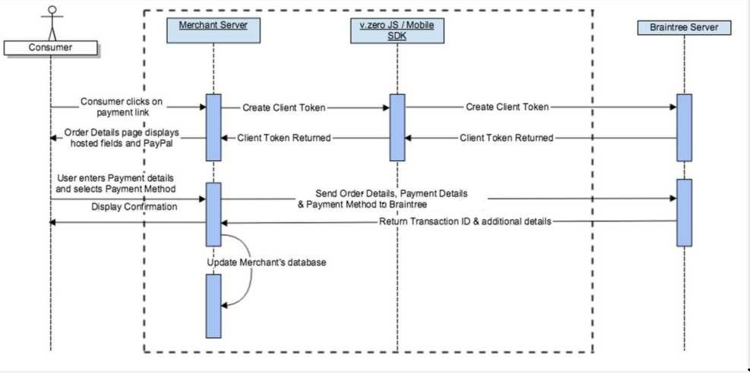

*Figure 2. Interaction diagram demonstrates the add-on layering approach*

1. Once a merchant generates a Client Token, the merchant invokes the Braintree JavaScript SDK to display the 'Hosted Fields' (credit card number, expiration date, and cvv2) and/or PayPal shortcut button (PayPal integration via Braintree).
2. After the customer enters their card details, the Braintree JavaScript SDK captures the card number, expiration date, and cvv2 details and upon the form being submitted, receives a payment method nonce from Braintree server.
3. In case of PayPal integration via Braintree - PayPal checkout flow is initiated, and in case successful customer authorization payment method nonce is returned from Braintree server.
4. Payment method nonce along with payment details is sent from UI to merchant server.
5. Braintree payment adapter creates a transaction using a payment method nonce and payment details through Braintree Java API.

## Deployment View

Braintree-Hybris integration was built using Hybris Add-on concept described in [Hybris Wiki (Add-ons are built on top of the existing Hybris Commerce Suite to extend the functionality of the Hybris Commerce Accelerator).](https://wiki.hybris.com/display/accdoc/hybris+AddOn+Concept) This let us extend payment functionality without editing the core code base. Detailed deployment steps are covered in the Installation Guide.

## Implementation View

Given hybris Braintree Add-on extends default hybris Commerce Accelerator Multistep Checkout Flow therefore it can be installed only on hybris Commerce Accelerator storefront. In case applying this Plugin to non-accelerator storefront only Braintree (contained hybris Braintree payment adapter) and braintreecscockpit extensions can be used. and braintreeb2baddon should be replaced with custom extension implemented for integration Hybris Braintree payment adapter with custom merchant storefront using given hybris Braintree Add-on as example.

Given Hybris Braintree Add-on is implemented using the three-layer model of the Hybris Commerce Accelerator

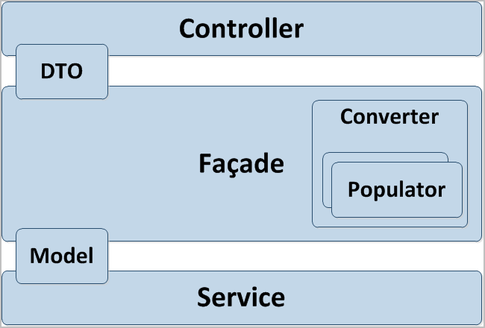

*Figure 3. Three-layer model of the hybris Commerce Accelerator*

Attached “bt_hybris class_diagramm_v.5.2-5.6” and “bt_hybris class_diagramm_v.5.7” Class Diagrams show class hierarchy implemented for extending Commerce Accelerator Multistep Checkout Flow with Braintree payment adapter for Hybris 5.2-5.6 and 5.7 versions.

## Security: Authentication and Authorization

In order to work with Braintree payment gateway, valid credentials including public and private keys need to be obtained and used:

braintree.merchant_id=vbjt6q2zp8nq4vgh

braintree.public_key=7zyy96mftydc47sp

braintree.private_key=2a48f4b9a1ca941a4eec76eaca037d8e

**Note** that this is just an example of credentials; don’t try to use them for any purposes.

You have to register on Braintree Sandbox to get those credentials..

1. Installation and Configuration

## Configuration with PayPal

For development and testing purposes you firstly need to register PayPal Sandbox business account at <https://www.developer.paypal.com/>

You will also need a personal PayPal Sandbox account to make test payments from it.

**Access Developer Portal and Create a PayPal Sandbox Account**

1. Go to [http://www.developer.paypal.com a](http://www.developer.paypal.com/)nd log in (Production PayPal credentials are required to access the developer portal)

2. Click **Dashboard** link at the top of the page

3. Click **Accounts** in the Sandbox section

4. You can now create a Sandbox account to receive test API credentials. Click **Create Account** at the top of the page and populate the following fields:

|  |  |
| --- | --- |
| **Account type** | Tick either the **Personal** or **Business** radio button. |
| **Email address** | The email address doesn't need to be a real email address; the Sandbox doesn't send any email outside of the Sandbox environment. Email to Sandbox accounts, generated as a result of your test API requests, are listed on both the [Notifications](https://developer.paypal.com/webapps/developer/dashboard/email) tab on the Developer site, as well as on the [Sandbox test site.](https://www.sandbox.paypal.com/webapps/profile/)  Use the assigned email value to reference this test account in your API calls, and to log in to the Sandbox site when you want to review the details associated with the account. |
| **Password** | The password must be 8-20 alpha-numeric characters in length. Use the password to log in to the Sandbox site as the test account. |
| **First and Last names** | The optional name fields accept alpha-numeric characters. |
| **PayPal balance** | While this field is optional, it's a good idea to create test accounts with positive bank balances. Enter an integer value between 1 and 5000. |
| **Bank Verified**  **Account** | You should create both *Verified* and *Unverified* test accounts so you can fully test your application. |
| **Select Payment**  **Card** | Test payments made with different payment cards by selecting either **Discover** or  **PayPal**.  *(Personal accounts only.)* |
| **Credit card type** | You must select a single credit card type for each test account. The Sandbox associates a mock credit card number with the account. |
| **Log in with**  **PayPal** | Tick the **I want to add Log in with PayPal to my site** box and complete the following fields to enable Log In with PayPal testing:  **1. Display name**  **2. Return URL**  **3. Privacy policy URL**  **4. User agreement URL**  *(Business accounts only.)* |

5. Once the follow details have been entered click the **Create Account** button

6. To locate the API credentials for your Sandbox PayPal account, click on the account you would like to view credentials for then select the **Profile** link.

7. Navigate to the API credential tab and copy your credentials:

## Installing Add-on

### Downloading Add-on

## For Hybris B2B versions 5.7 – b2bacceleratoraddon extension must be installed if it has not yet installed.

* + 1. Update localextensions.xml:

Add <extension name=" b2bacceleratoraddon "/>

* + 1. Run installation command
    2. Stop Hybris if it’s running with Ctrl+C
    3. Run ..\bin\platform\setantenv.bat if it was not applied in this terminal
    4. Go to ..\bin\platform and run installation command:

ant addoninstall –Daddonnames = b2bacceleratoraddon - DaddonStorefront.asianpaintsb2bstorefront=”asianpaintsb2b”

### Downloading Add-on

1. Download adapter archive from the hybris marketplace

2. Unpack archive and place folders **braintree**, **braintreeb2baddon** and **braintreecscockpit** into

**..\bin\custom**

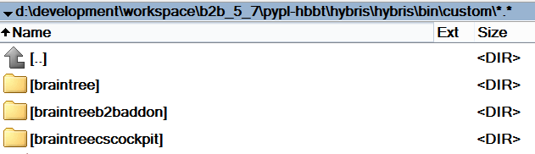

Figure 4.2.1 Add-on repository location for Hybris **B2B 5.7**

### Update localextensions.xml

1. Check the presence of **<extension name="addonsupport" />**

2. Add following extensions

* **<extension name="braintree"/>**
* **<extension name="braintreeb2baddon"/>**
* **<extension name="braintreecscockpit"/>**

Check the presence of target storefront extension

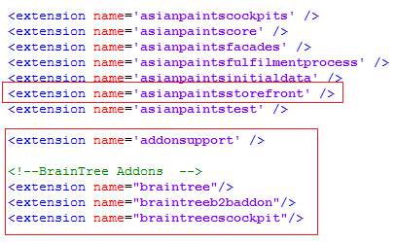

**Figure 3. Example of configured localextensions.xml**

### Run installation command

1. Stop hybris if it’s running with Ctrl+C

2. Run **setantenv.bat** if it was not applied in this terminal

3. Go to **..\bin\platform** and run installation command:

**ant addoninstall -Daddonnames=paypaladdon - DaddonStorefront.asianpaintsstorefront=asianpaintsstorefront**

### Main configurations

1. Go to .**.\bin\custom\paypal\project.properties**

2. Find and update the following configurations: **paypal.username**, **paypal.password**, **paypal.signature** and **paypal.seller.email** with your API credentials from PayPal business account.

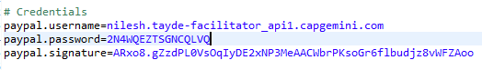

**Figure 6. Example of configured project.properties**

### Rebuild the system

### Update

At this step you may make **full initialization** through hAC if you use clean hybris for testing purposes. And that is 1 sufficient step to finish add-on installation.

If you can’t perform full initialization then you need to make more complicated update:

1. Go to hAC->Platform->Update

2. Choose 4 update options **Update running system**, **Clear the hMC configuration from the database**, **Create essential data**, **Localize types**

3. Choose add-on components to update: **paypal**, **paypaladdon**, **paypalcscockpit**

4. Then make update

5. After update finishes go to **Console**->**Impex Import**.

You must insert script here. You should use one of ready scripts (if it is accelerator based installation) or customize one for your content catalog.

You can find ready scripts in add-on files:

**..\bin\custom\paypaladdon\resources\paypaladdon\import\contentCatalogs\**

For example, during testing we used **cms-content** and **cms-mobile-content** from

**powertoolsContentCatalog**.

6. Import content

7. Go to hMC->Catalog->Catalog Management Tools->Synchronization

8. Choose Source Catalog Version and execute Synchronization

1. Functional overview

## PayPal Express checkout

Add-on offers PayPal Express Checkout (via Braintree) to merchants through the use of the “Check Out with PayPal” shortcut button. The solution is implemented into out-of-the-box B2B (for 5.7 version) hybris accelerators (both cart and mini-cart are affected).

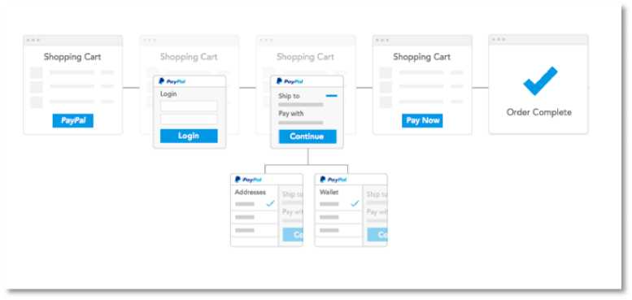

*Figure 7 General Flow for Checkout with PayPal*

Express Checkout with PayPal provides the ability to either do single use payments where the customer checkouts each time (PayPal checkout via Braintree); or multiple uses where the customer need only checkout the first time and any future payments are processed out of the Vault (PayPal Vault via Braintree).

Anonymous user (who hasn’t hybris account) has possibility to pay with PayPal Express Checkout without registering in Hybris accelerator.

Assuming that buyer has a PayPal account, he/she can initiate the Express Checkout flow on the shopping cart page or in-mini cart by clicking the Checkout with PayPal button.

For Express Checkout with PayPal Address page is skipped (shortcut) in order to speed up the checkout time. Shipping and billing addresses are returned from PayPal account.

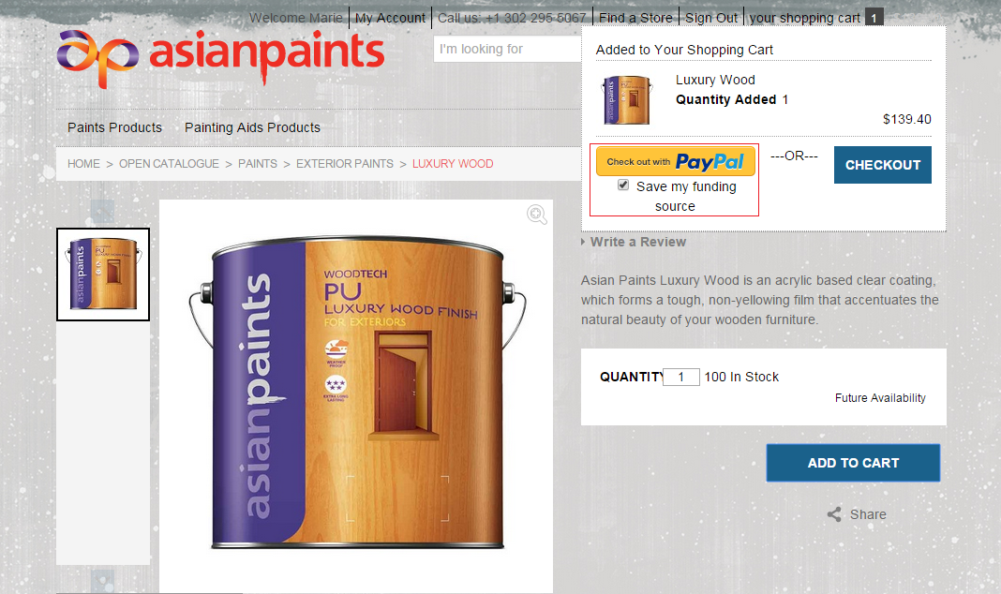

*Figure 8. PayPal Express Checkout in Mini Cart*

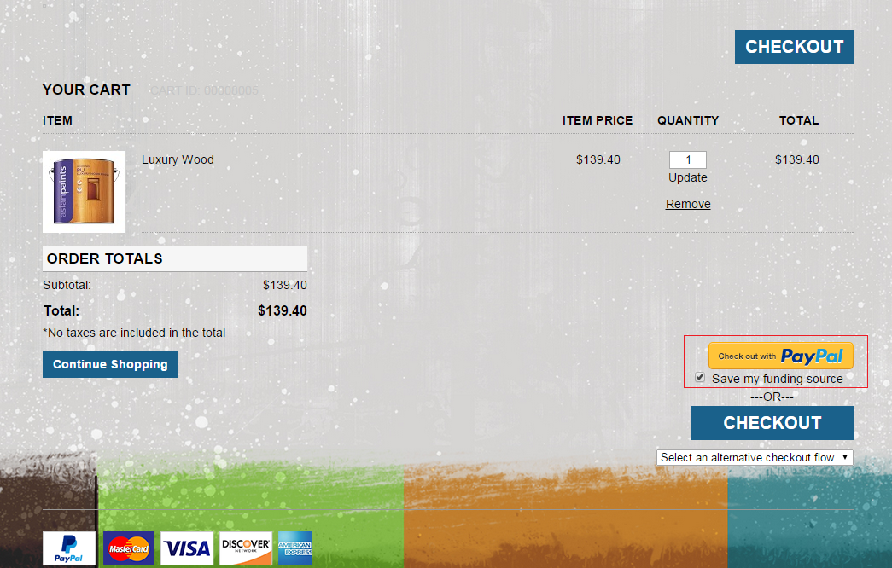

*Figure 9. PayPal Express Checkout in Shopping Cart*

1. The PayPal Express Checkout Shortcut will appear on the Shopping Cart page of hybris box B2B (for 5.7 version) accelerator and also in mini-cart.
2. Customer can choice between PayPal Vault and Checkout flows by checking or unchecking “Save my funding source” checkbox. The Vault flow (when “Save my funding source” checkbox is checked) will save the payment method for later reference, and Checkout flow (when “Save my funding source” checkbox is unchecked) is for one-time payments when you do not want to save the payment method
3. If a customer clicks on PayPal Express Checkout Shortcut, the PayPal Checkout Login popup is rendered

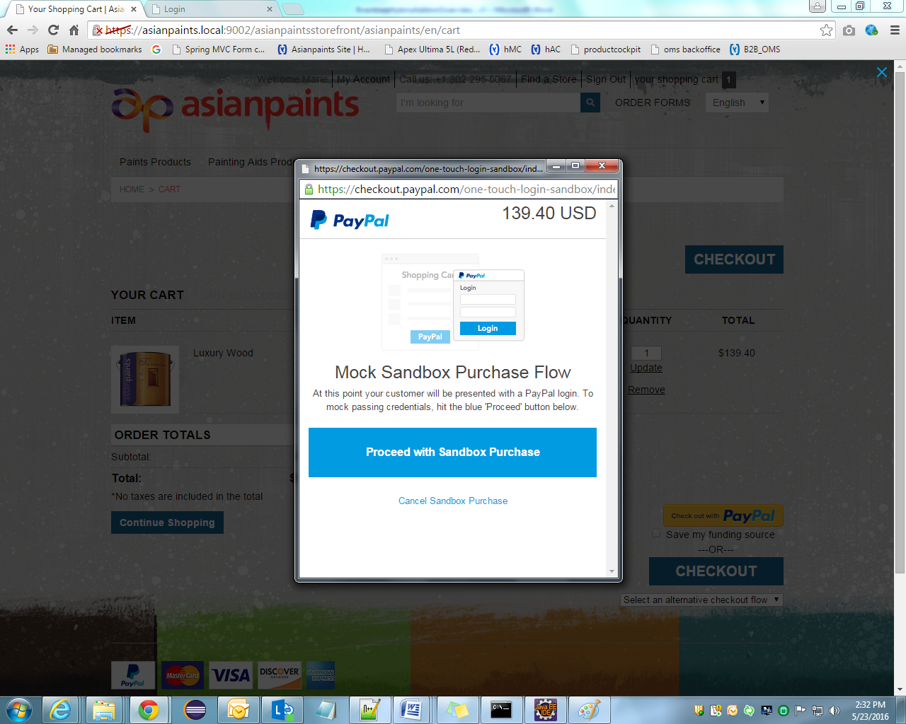

*Figure 9. PayPal Checkout Login Popup*

1. After success PayPal authorization customer will be redirected back to the hybris B2B accelerator review page

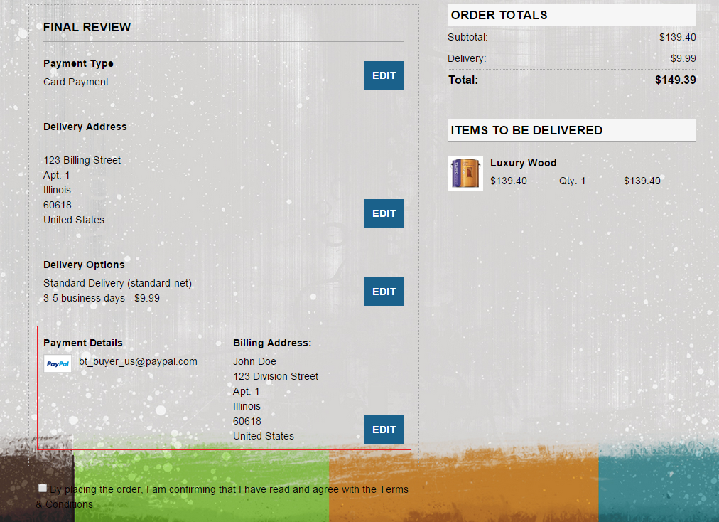

*Figure 10. Final Review page on PayPal Express Checkout*

1. Once on order review page they can click “Place order” to process their order and payment.

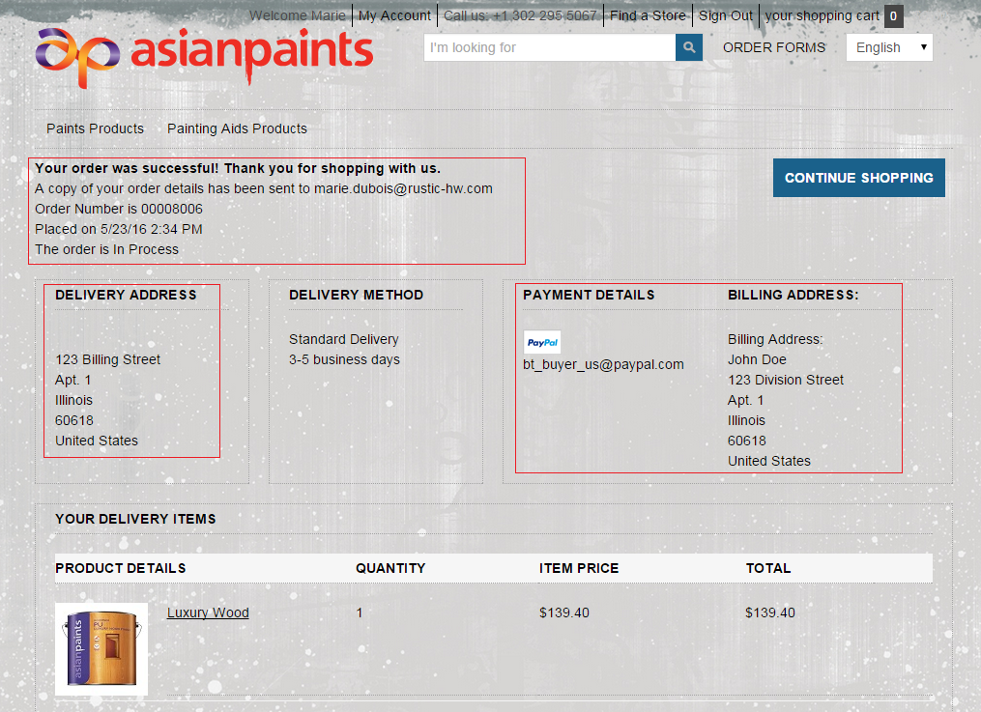

*Figure 11. Order Confirmation Page on PayPal Express Checkout*

## PayPal Custom UI checkout along with other payment methods

Checkout with PayPal Custom UI is very similar to PayPal Express Checkout in regards to parameter setup however it differs as far as process flow. Typically, the Checkout with PayPal Custom UI integration is listed with other payment methods such as credit cards and the overall order experience is matched to what a consumer would go through with a credit card. Therefore, if a consumer 'clicks' on the 'PayPal' payment method they are sent to PayPal to enter their credentials and finish checking out.

Customer enters shipping and billing addresses during Checkout process.

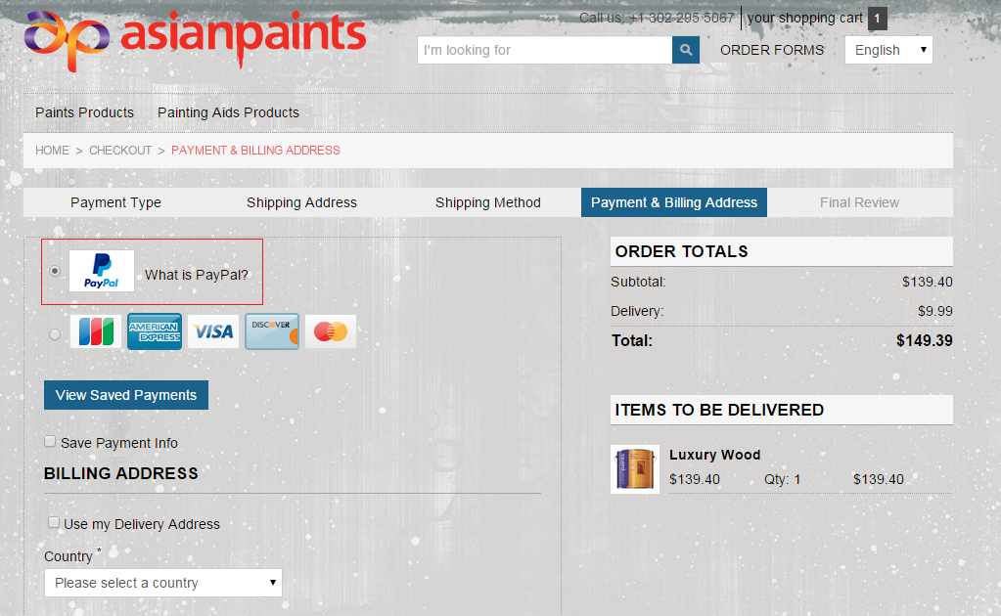

*Figure 12. Multi Checkout Page (Payment Details Step) with chosen PayPal option*

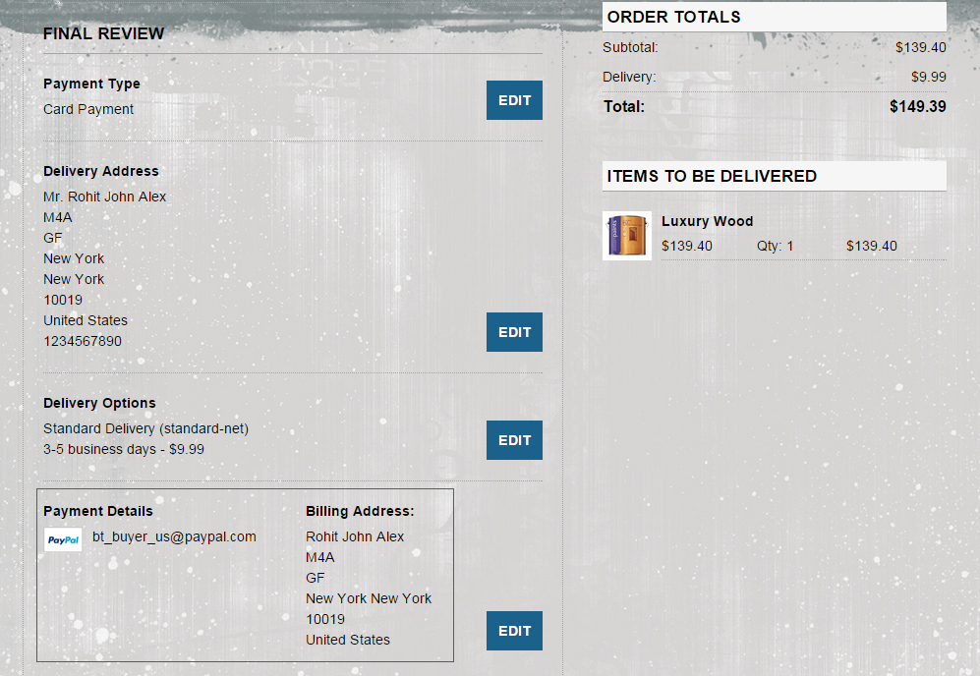

*Figure 13. Final Review page on Custom PayPal Checkout*

### Custom Braintree Integration with Hosted Fields

For a merchant to be eligible for the easiest level of PCI compliance—SAQ A—payment fields cannot be hosted on merchant checkout page. All payment fields (credit card number, CVV, and expiration date) must be hosted on an external payment gateway's domain and presented to the user in a frame. All card sensitive fields are replaced with frames that are rendered via the JavaScript SDK thus providing a PCI compliant solution.

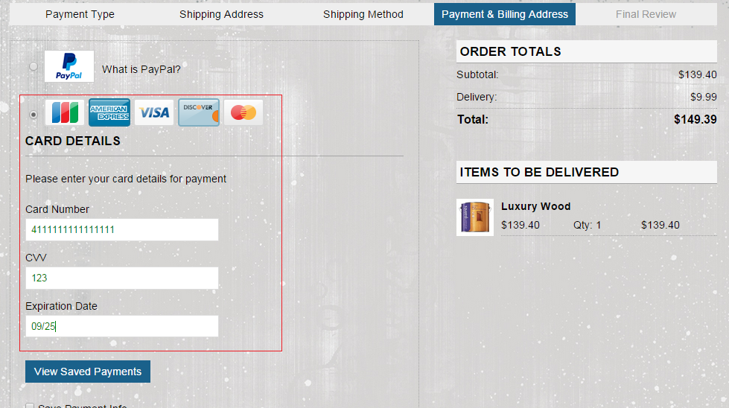

*Figure 14. Multi Checkout Page (Payment Details Step) with chosen Credit Card option*

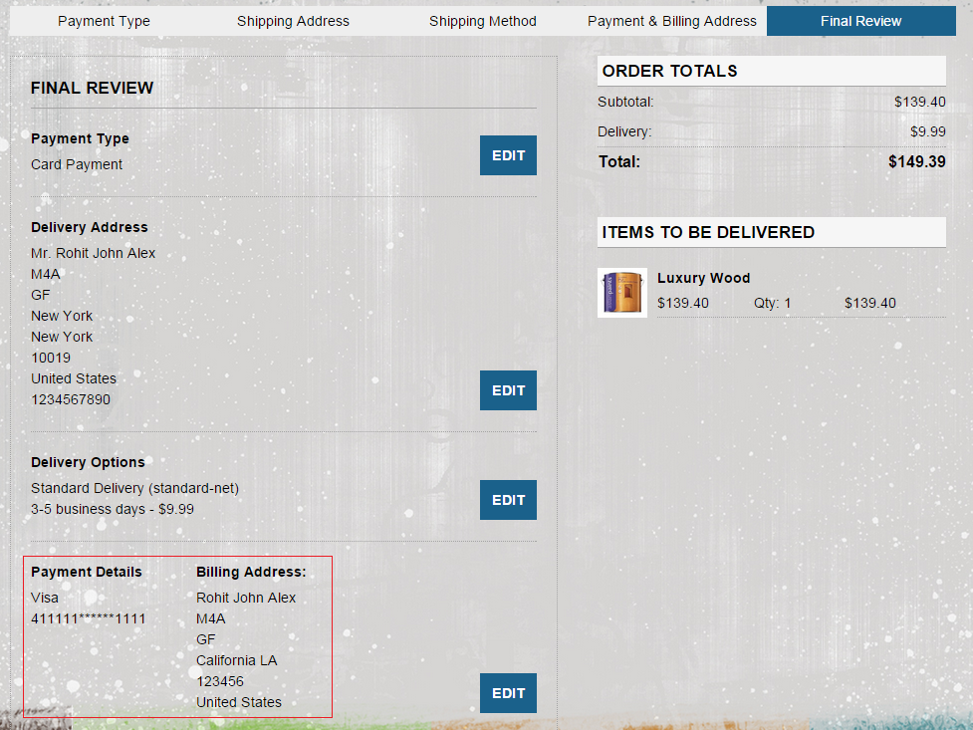

*Figure 15. Final Review page on Credit Card Checkout*

### Replenishment orders for 5.7 B2B

The plugin provides the ability to pay orders scheduled on a regular basis using Braintree Credit Card payments or PayPal authorization via Braintree.

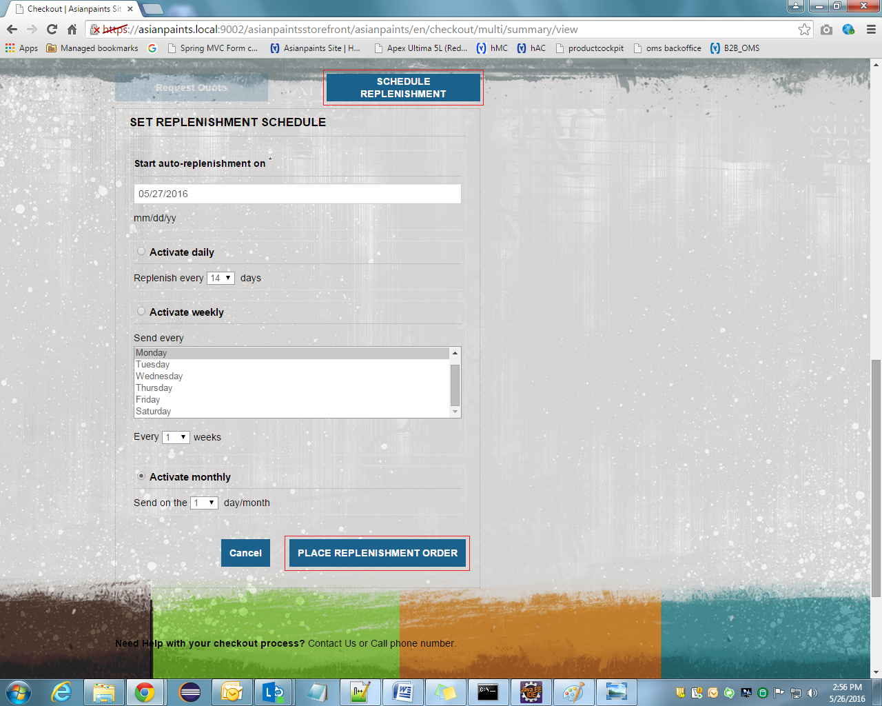

*Figure 16. Final Review page on B2B 5.7*

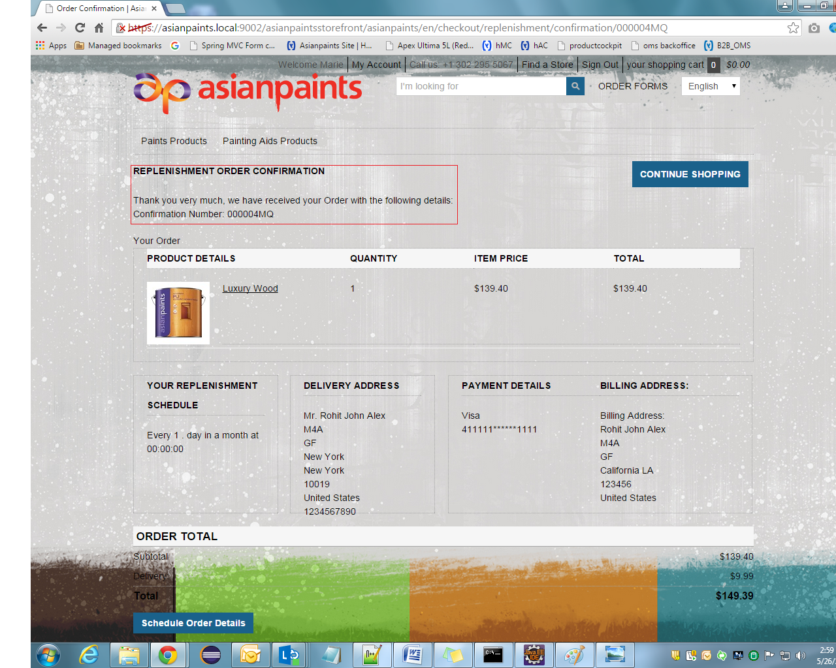

*Figure 17. Replenishment Order Confirmation Page*

### Back-office operations with Braintree Payments

**Braintreecscockpit** extension extends **cscockpit** by adding Braintree payment functionality.

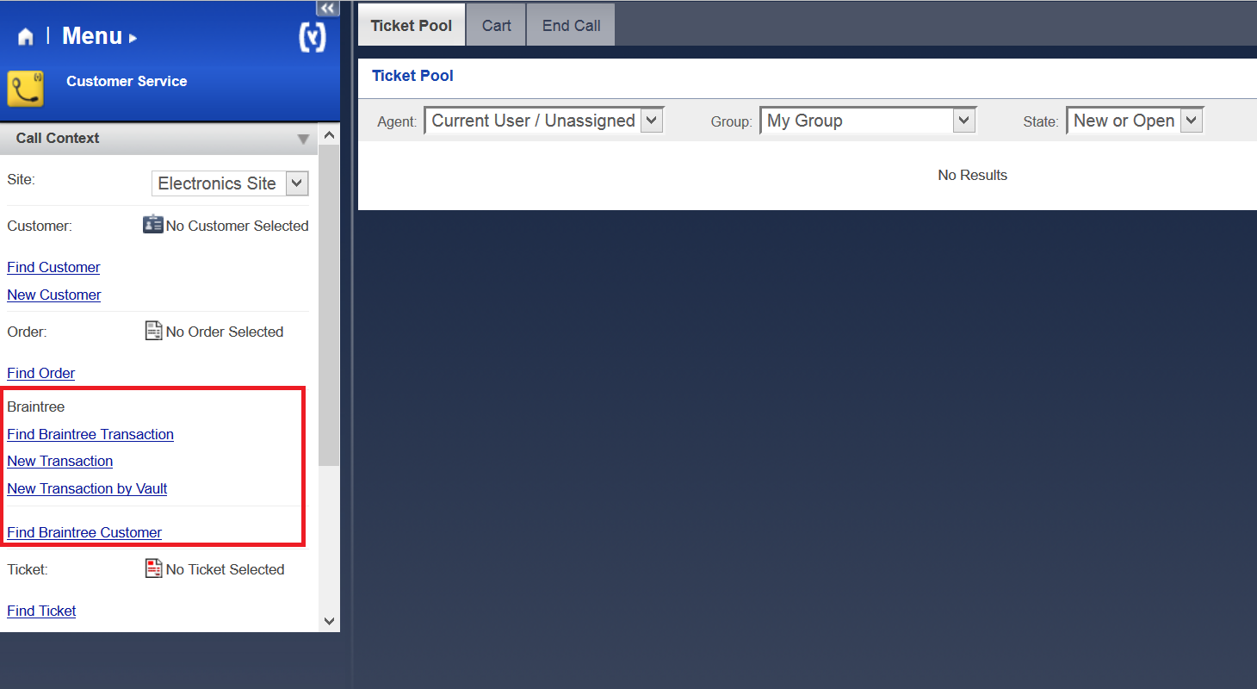

*Figure 18. Braintree Section of CSCockpit*

### Find Braintree Transaction Section

The plugin provides the ability to search for a set of transactions based on specific filters

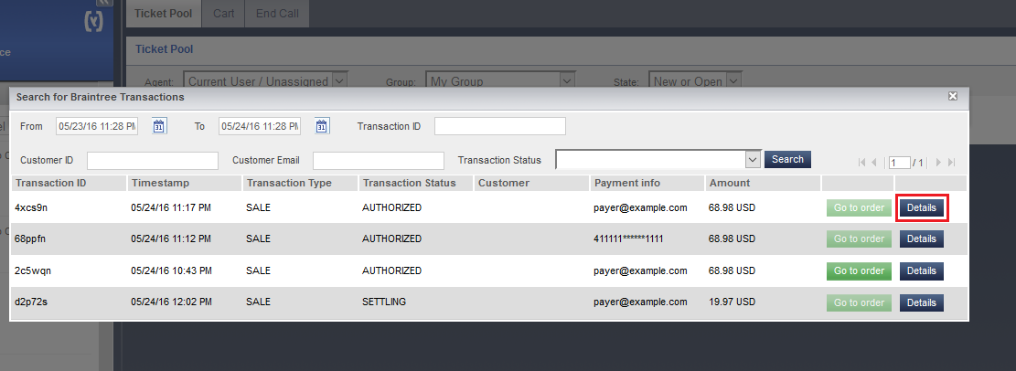

*Figure 19. Search for Braintree Transactions Pop-up*

There is possibility to get details on a specific transaction or go to appropriate order.

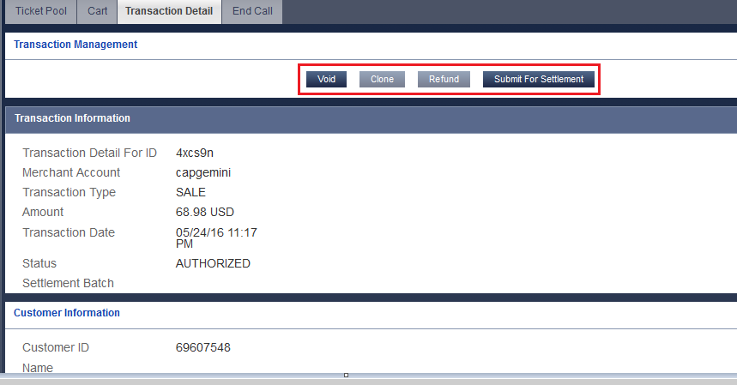

*Figure 20. Braintree Transaction Details Tab*

There is set of available transaction actions according to current transaction status.

The Plugin provides the ability to void a transaction that has a status of 'authorized' or 'submitted For Settlement'.

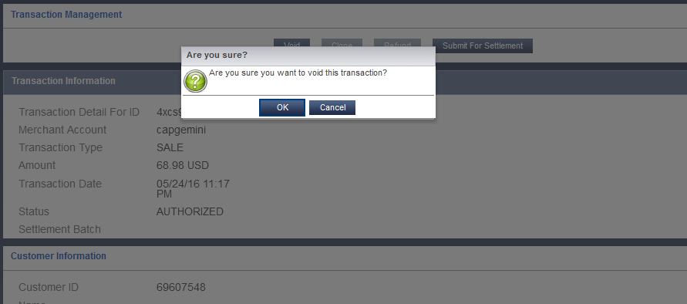

*Figure 21. Void Braintree Transaction Pop-up*

The plugin provides the ability to capture or settle an authorization later. The plugin sends a request to Braintree to 'submit for settlement'.

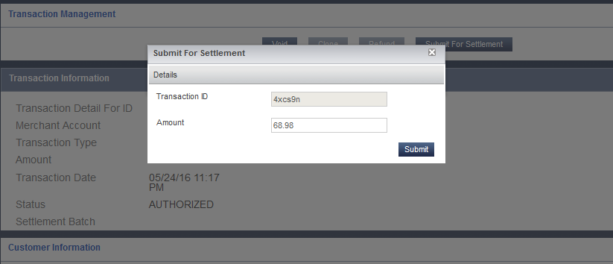

*Figure 22. Submit for Settlement Braintree Transaction Pop-up*

The plugin provides the ability to refund a transaction for a specific amount or the whole amount.

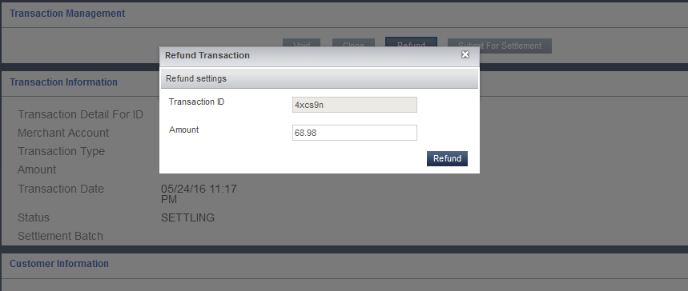

*Figure 23. Refund Braintree Transaction Pop-up*

The plugin provides the ability to clone a transaction. Cloning a transaction will create a new transaction by copying all the attributes, except amount, of the original transaction.

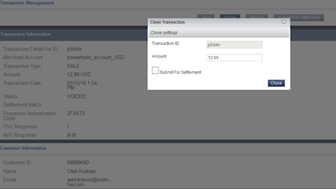

*Figure 24. Clone Braintree Transaction Pop-up*

In addition, plugin allows create new Braintree transactions by entering payment details or using payment method token.

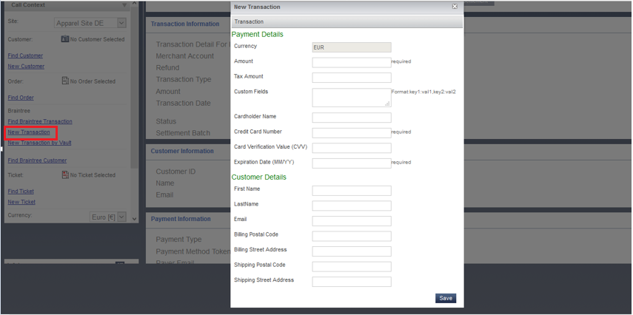

*Figure 25. New Braintree Transaction Pop-up*

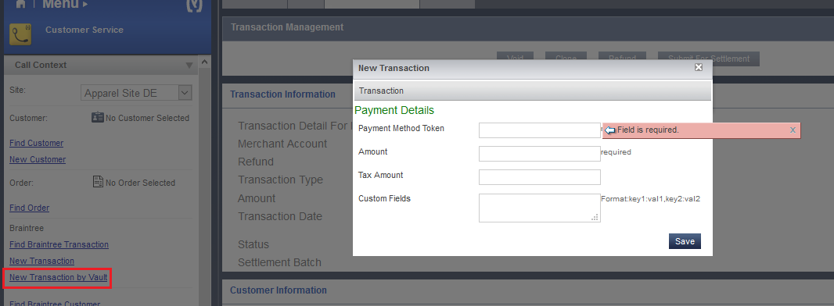

Figure 26. New Braintree Transaction by Vault Pop-up

### Find Braintree Transaction Section

Every hybris customer (hybris account) has vaulted as Braintree customer in case of paying with Braintree payment adapter.

The plugin is able to get customer details from the Braintree merchant's vault by passing in a customer id or customer email.

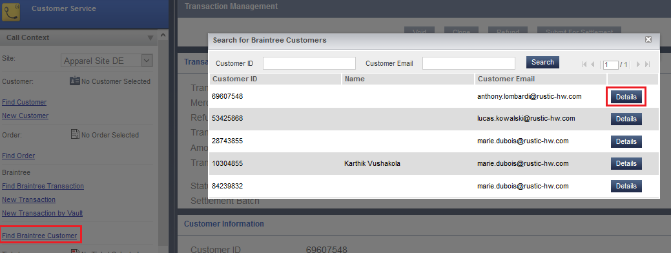

*Figure 27. Search for Braintree Customers Pop-up*

The customer details will include any payment method tokens, addresses, phone numbers, email addresses and other details that are associated with a particular Braintree customer.

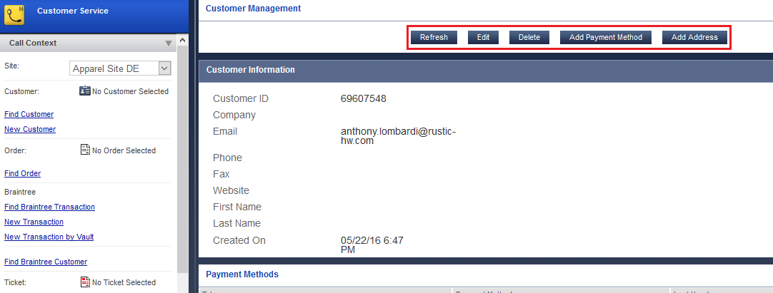

*Figure 28. Braintree Customers Details Tab*

User can edit a customer's details using edit action button.

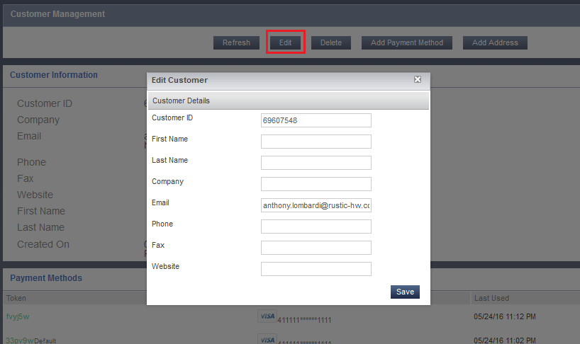

*Figure 29. Braintree Customers Edit Pop-up*

The plugin is able to delete a customer from the merchant's Braintree vault.

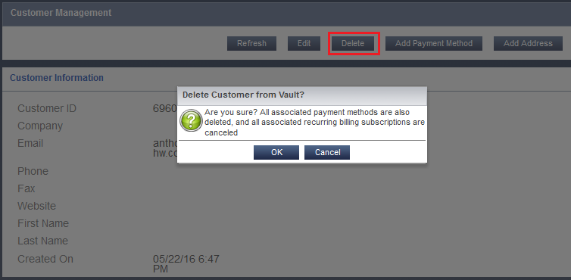

*Figure 30. Delete Braintree Customer Pop-up*

The plugin is able to lookup, add, update, and delete a payment method to a Braintree customer.

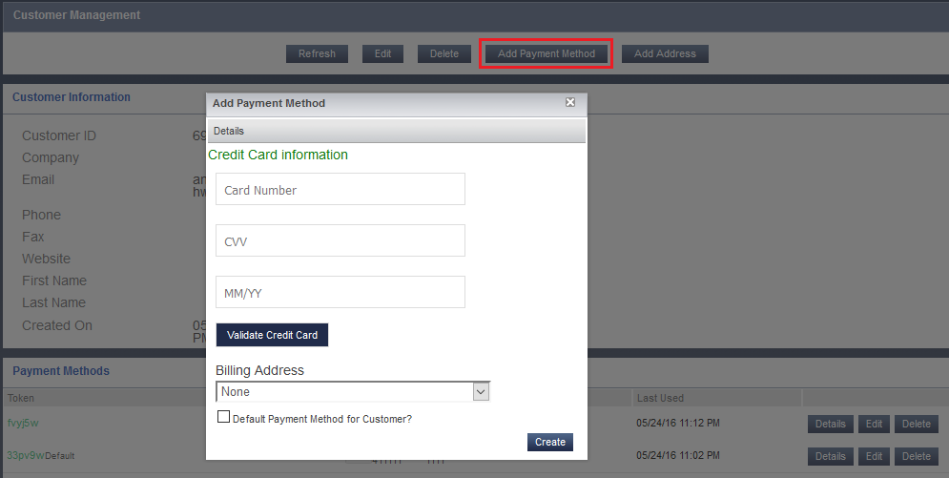

*Figure 31. Add Braintree Payment Method Pop-up*

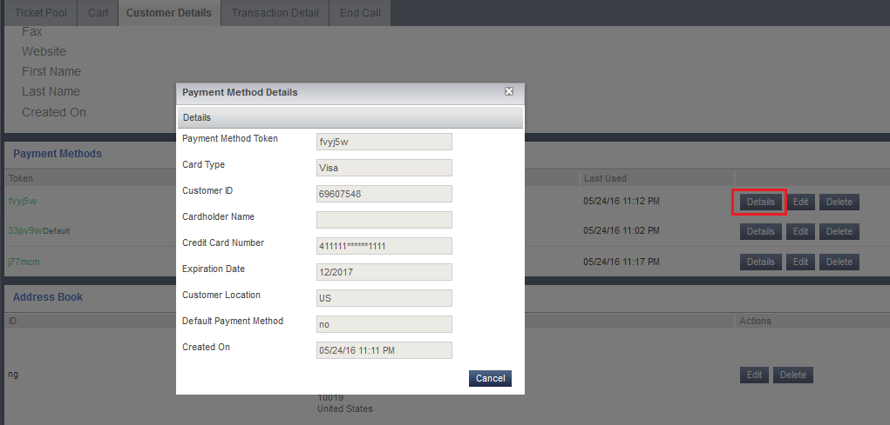

*Figure 32. Braintree Payment Method Details Pop-up*

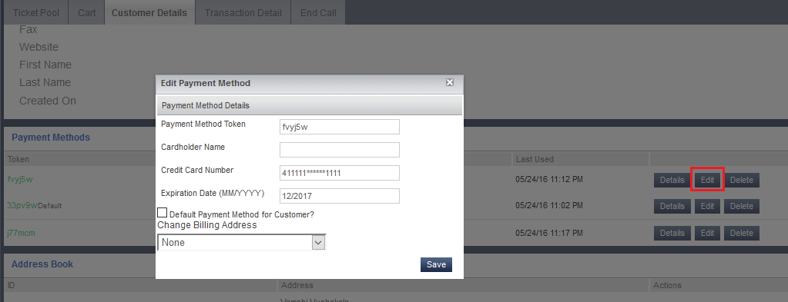

*Figure 33. Edit Braintree Payment Method Pop-up*

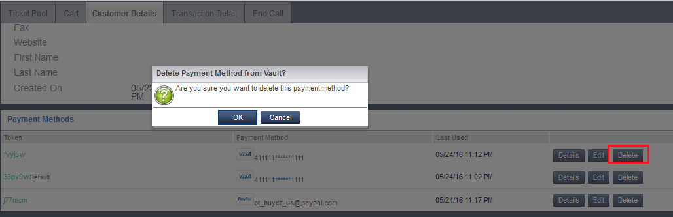

*Figure 34. Delete Braintree Payment Method Pop-up*

The plugin synchronizes Braintree payment methods with Payment Details belonging to customer account on Hybris Accelerator storefront

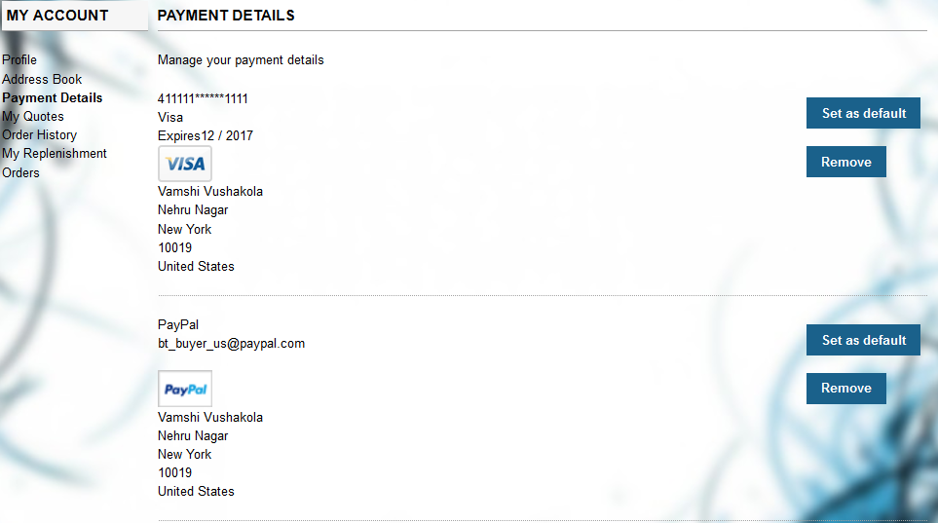

*Figure 35. Accelerator storefront Account Payment Details*

User can enter his credit card information (number, cvv, date) or use PayPal authorization and save this payment method by checking “Save payment Info” checkbox on Accelerator Checkout flow. Next time he will be able to pay by choosing this previously stored payment method without entering his credit card details or doing PayPal authorization again.

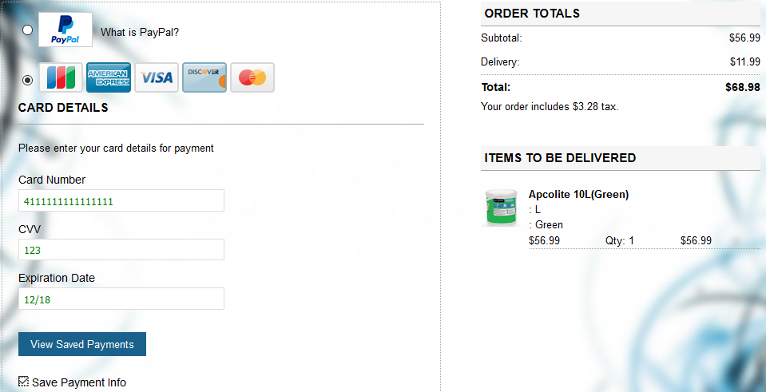

*Figure 36. Chose ‘Save Payment Info’ option on Accelerator Checkout Flow*

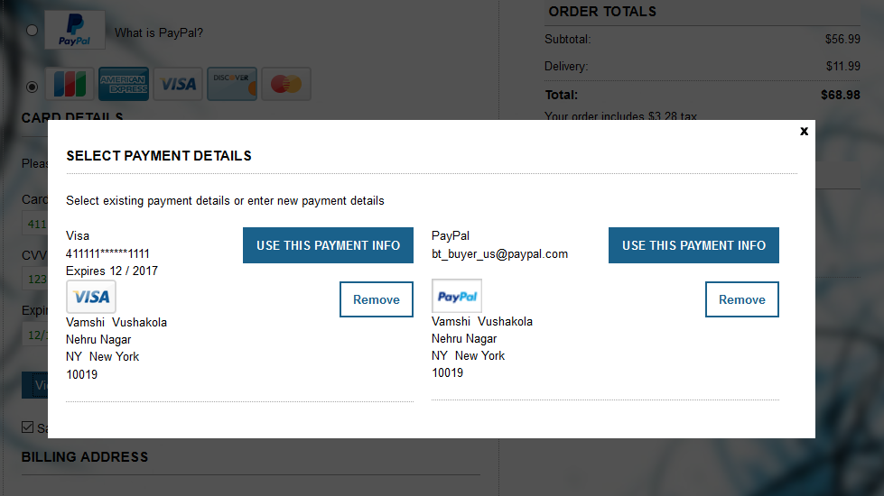

*Figure 37. Select Stored Payment Method*

The plugin is able to add, update, and delete Address Book of Braintree customer.

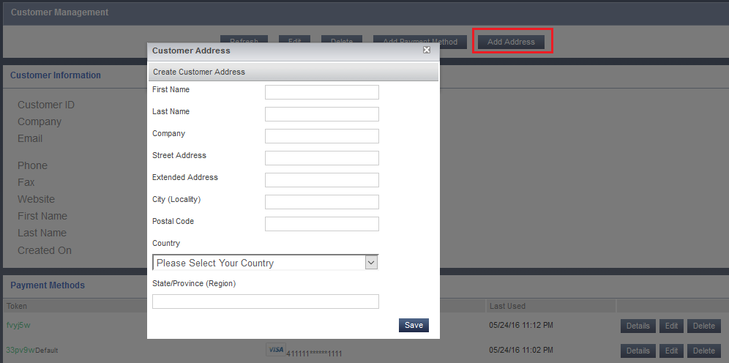

*Figure 38. Add Braintree Customer Address Pop-up*

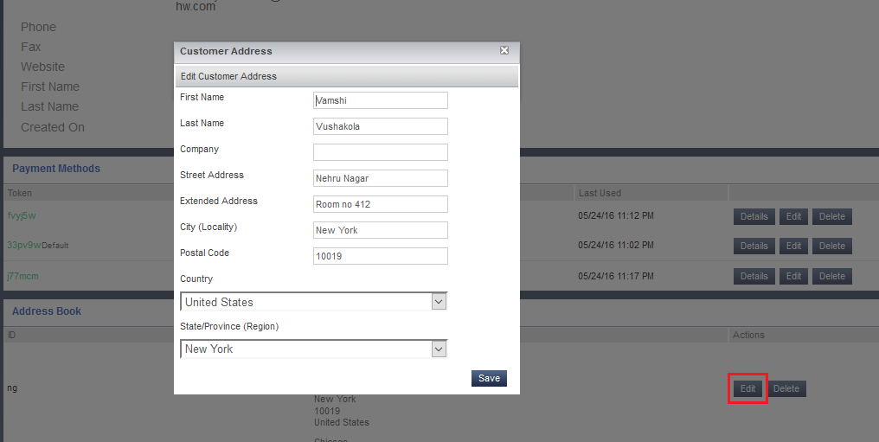

*Figure 39. Edit Braintree Customer Address Pop-up*

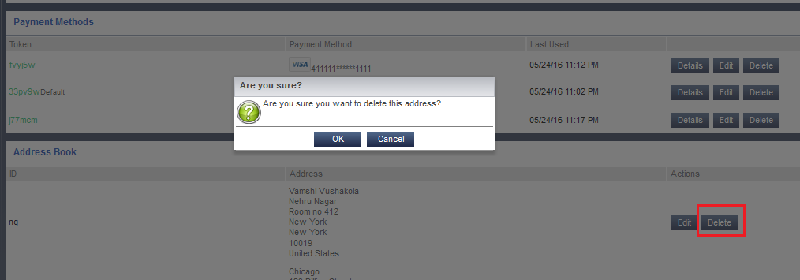

*Figure 40. Delete Braintree Customer Address Pop-up*

The plugin synchronizes Braintree customer Address Book with Address Book belonging to customer account on hybris Accelerator storefront

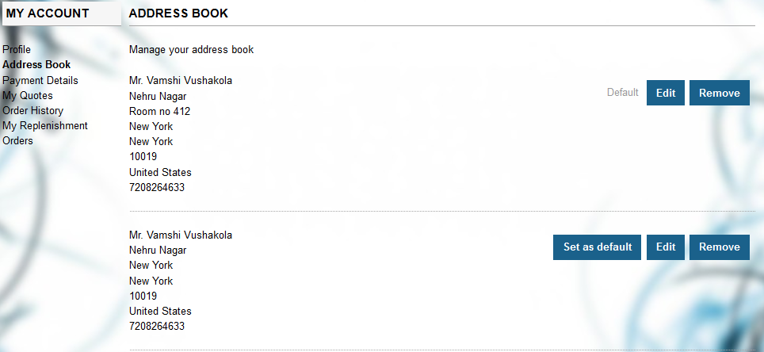

*Figure 41. Accelerator storefront Account Address Book*

### Error Handling

Basic handling of Braintree errors is implemented with showing error text sent by Braintree.

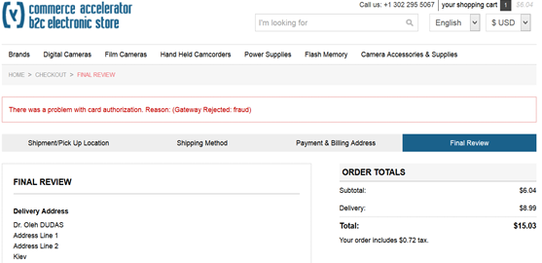

*Figure 43. Display Braintree Error Text.*

Credit card payment information is verified by Braintree on the client side.

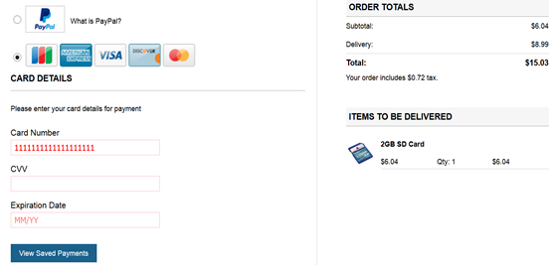

*Figure 44. Braintree Credit Card Client Side Validation*